DATA VISUALIZATION PROJECT

BY USING

POWER BI

EMPLOYEE DATA ANALYSIS ON REAL TIME DATASET

BY

APURVA MOTE

In today's highly competitive digital landscape, establishing a strong online presence is crucial for businesses seeking growth and success. A well-designed website serves as the cornerstone of this online presence, acting as a virtual storefront and an information hub for potential customers. However, a visually appealing website alone is not sufficient to attract visitors and drive business growth. Search Engine Optimization (SEO) plays a pivotal role in ensuring that a website is easily discoverable by search engines and ranks prominently in search engine results.

Power BI is a powerful cloud based and On-premises suit of business analytics tools developed by Microsoft to make it easy to combine data from multiple sources, analyze and visualize information and share insights. It also provides self-service business intelligence capabilities, where end users can create reports and dashboards by themselves, without having to depend on information technology staff or database administrators. Power BI allows us to share dashboards and reports with the right people.

It has flexibility as it operates with all leading operating systems like Windows, IOS and Android. Power BI provides cloud-based BI services, known as "Power BI Services", along with a desktop- based interface, called "Power BI Desktop". It offers data warehouse capabilities including data preparation, data discovery and interactive dashboards. Power BI can also provide executive dashboards for administrators or managers, giving management more insight into how departments are doing.

The common flow of activity in Power BI looks like this:

* Bring data into Power BI Desktop, and create a report.
* Publish to the Power BI service, where you can create new visualizations or build dashboards.
* Share dashboards with others, especially people who are on the go.
* View and interact with shared dashboards and reports in Power BI Mobile apps.

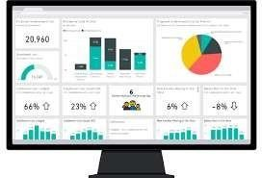

*Figure 1:POWER BI DASHBOARD*

POWER BI

It is a collection of tools, services, and connectors that helps a user integrate, analysse, and visualize raw business data and convert it in the form of dashboards or live reports. These dashboards can then be shared with other users or stakeholders to make better decisions that eventually increase profitability.

Power BI provides a scalable platform that helps the user to connect, visualize, and share the data with other users or stakeholders to gain deeper insights into the business. It is available in both free and paid versions.

The free version only offers Power BI tools like and Power Q&A to reports or dashboards. Whereas, Power BI pro comes with Power BI Service that provides live report sharing, Power View, and Power BI Apps which gives great help while working with your Power BI projects.

Microsoft Power BI architecture enables non-technical users to get actionable insights into their business data without spending much time and resources to learn about the system. Using charts and graphs, users can understand the current state of the business and the actions needed to improve it.

Power BI Components

In this section, you will read about the components of Power BI and the important role they play to implement Power BI capabilities.



*FIG NO.2 Figure 2: POWER BI COMPONENTS*

What is Power BI Query?

With Power Query, you can collect, transform, and analyse distinct information from multiple data sources. In other words, it is a data transformation and mashup tool that helps you bring in information from different sources on a single platform.

What is Power BI Pivot?

Power Pivot is a data modelling technique that uses the Data Analysis Expression (DAX) language to create simple and complex data models. With this feature in the BI toolkit, you can do numerical computation and establish relationships between different data sources.

What is Power BI View?

You can add Power View on SQL Server or Spread Share and create graphs, maps, charts, and other visuals with simple drag-n-drop features. Power View can connect and filter different data sources to make a report on a single device.What is a Power BI Map?

With Power Map, you can plot more than a million rows of data on Bing Maps in the form of 3D visualizations. Based on the country, longitude, and latitude, Bing Maps shows the exact geospatial visuals of complex business information. This proves to be beneficial when you want to get sales insights from certain locations.

Power BI Architecture

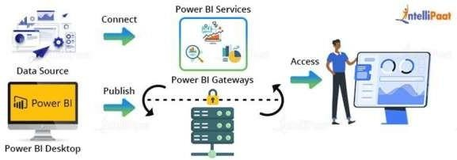

*Figure 3:DIAGRAMATICAL VIEW OF POWER BI MAPS*

Power BI architecture is a service built on top of Azure. There are multiple data sources that Power BI can connect to. Power BI Desktop allows you to create reports and data visualizations on the dataset. Power BI gateway is connected to on-premise data sources to get continuous data for reporting and analytics. Power BI services refer to the cloud services that are used to publish Power BI reports and data visualizations. Using Power BI mobile apps, you can stay connected to their data from anywhere. Power BI apps are available for Windows, iOS, and Android platforms.

Advantages of Power BI

Affordability: A major advantage of using Power BI is that it is inexpensive compared to other cloud service providers. The Power BI Desktop version is free of cost, you can download and start making the reports on your computer. However, if you want to share your reports on the cloud you have to pay 9.99$ per user per month.

Excel Integration: In Power BI, you can also save data to Excel. No matter how great the data is presented using Graphs, maps and charts using data visualization tools, people still tend to have the data in their excel sheet. For example, you can get the data of a manufacturing unit for the past six months within a few clicks from Power BI.

Custom Visualization Power BI offers a wide range of custom visualizations where developers can take your requirements and convert them to KPI’s, charts, graphs, maps etc.

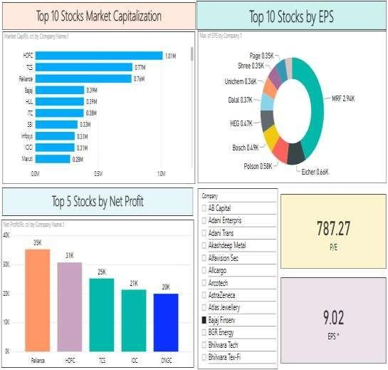

*Figure 4:BY MARKET VIEW DASHBOARD OF POWER BI*

PIE CHART DASHBOARD

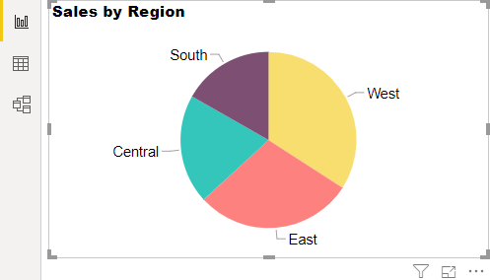

*Figure 5:Pie chart visualization on sales by region through directions.*

**BY GRAPHICAL WAY DASHBOARD**

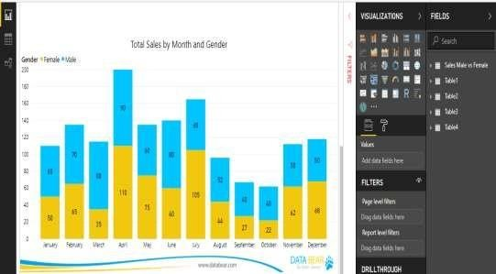

*Figure 6:Diagrammatical view of sales by MALE and FEMALE by monthly graph*

OBJECTIVES OF STUDY

* To understand use of Microsoft Power BI Tool in Indoor Systems Solution Pvt. Ltd.
* To learn data exploration and visualization with interactive reports and dashboards.
* To run reports and surface insights based on a company's Dumy data.
* Using the visualization tool in Power BI to create dashboards.

Below are the tasks that were carried out me as an business analytics intern they are as follows :-

1. To understand How to use Microsoft Power BI Tool.
2. To understand and learn Components of Power BI.
3. Used Features of Power BI.
4. Learned Three stages of data analytics by using dumy data in Power BI.
5. Analysing the data from Excel.
6. Using the visualization tool in Power BI to create dashboards.
7. To work with project team to validate requirements, design and analysis model.

Moreover, we work closely with Project Manger in most of the projects, to… Design and review the Task Plan, Test Plan, or any plans and Test Cases Processing change requests

Tracing the requirements during implementation Learning the analytical tools.

Biweekly Tasks: Depending upon the project period and complexity, we should facilitate team meetings in order to evaluate status of the project; also taking Meeting Minutes and distribute them to Senior Management to report the status of the project.

* 1. To understand How to use Microsoft Power BI Tool

As a Business Analytics Intern at Embedded Software Solution Pvt. Ltd., my first task was to use and understand Microsoft Power BI Tool. Power BI Desktop is where analysts and other users can create data connections, data models and reports. The Power BI service is where those reports can be shared, so other users can view and interact with them.

To build a Power BI report, I take the following steps:

Connect the data sources.

With Power BI Desktop, we can connect to data from many different sources. For a full list of available dumy data sources, see Power BI data sources.

We connect to data by using the Home ribbon. To show the Most Common data types menu, select the Get data button label or the down arrow.

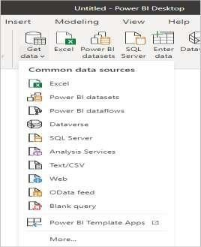

*Figure 8:Connect the data sources*

Next , To go to the Get Data dialog box, show the Most Common data types menu and select More. We can also bring up the Get Data dialog box (and bypass the Most Common menu) by selecting the Get Data icon directly.

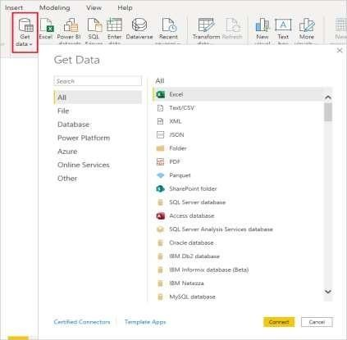

*Figure 9:Connect the data sources*

* Query the data to create reports based on user needs.

Below are the steps to use Query Editor in Power BI:-

* + Connect your data to Power BI. This can be done through the Get Data option, or by connecting to an online service such as SharePoint, Excel, or a database.
  + Once connected, create a report. This can be done by selecting the appropriate visuals from the Visualizations tab, or by using the Report view to create a report from scratch.
  + Use the Query Editor to refine your data. This allows you to apply filters, add calculated columns, and transform your data so that it can be used in the report.
  + Create relationships between different data sets, if needed. This will allow you to create more complex reports.
  + Use the Formatting tab to customize the look and feel of your report.
  + Use the Slicers feature to create interactive elements that allow users to filter the report data.
  + Publish the report to the Power BI service so that it can be accessed by other users.

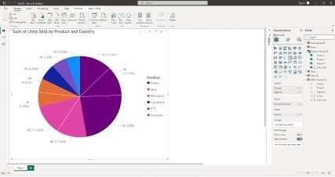

*Figure 10: Created Report with Visualization Tab*

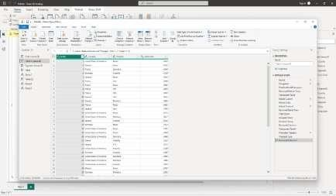

*Figure 11:Query Data Editor*

* + Publish the report to the Power BI service.

Publishing a report to the Power BI service requires the following steps:

* + Sign in to the Power BI service with your Microsoft account.
  + Select the “My Workspace” option from the left-hand navigation menu.
  + Select the “+ Create” button in the top-right corner.
  + Select “Upload” from the list of options.
  + Select the report you would like to upload from your computer.
  + Select the “Upload” button once the report has been chosen.
  + Select the “Publish” button to publish the report.

1. To understand and learn Components of Power BI

The next task was carried out by me is to learn component of Power BI. Power BI made of 6 main components, these components released in the market separately, and they can be used even individually. Components of Power BI are:

* + Power Query: Data mash up and transformation tool.

Here I use Power Query and to create Power Query in Power BI, first create a Data Model in Power BI Desktop by connecting to data sources. When the data is imported into the Data Model, Power Query will automatically be used to transform the data into a usable format.

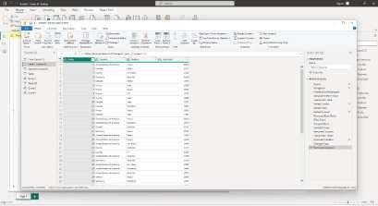

*Figure 12: Power Query Data Editor*

* + Power Pivot: In-memory tabular data modelling tool

Next component that I used is Power Pivot. Here To create a matrix in Power BI, first need to connect to data source and import the data into Power BI.

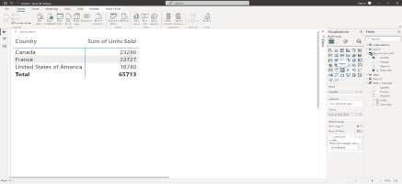

*Figure 13: Power Pivot*

Once the data is imported, use PowerPivot to create the matrix. To do this, open the PowerPivot window and select the columns and rows that you want to include in your matrix. Once you have selected the columns and rows, click on the “Create Matrix” button and specify the field names for the columns and rows.

* Power View: Data visualization tool

There are multiple Visualization tools are available in Power BI. I used some tools here like Pie Chart , line chart ,Column chart, Donut chart, Matrix , Card and Map etc.

**Analysing the data**

This is the task where I analyse some data of Product sales by Country Name , Unit Sold and Segment. The Data that I analyse through dashboard / worksheet are :-

* Count Of Annual salary of the employee by department Units Sold ?
* How Much Total business unit By Country Name ?
* How Many Business units ?
* What Count Of Segment And business Units by gender ?
* Sum Of Units And Count Of annual salary By Country And Segment ?

1. Using the visualization tool in Power BI to create dashboards

The last but not least task that I carried out was to create dashboards in Power BI . Below I describe some visualization tool that are used to create Dashboards and the visualization tools that I used here are :-

* + Pie Chart
  + Pivot Table (Matrix)
  + Card
  + Stacked Bar Chart
  + Line and Clustered Column Chart
  + KPI

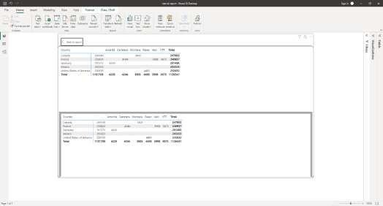

*Figure 14:Showing the selecting the dashboard.*

# Data Analysis

**Analysis:**

DASHBOARD VISUALIZATION AS PER THE DATA,

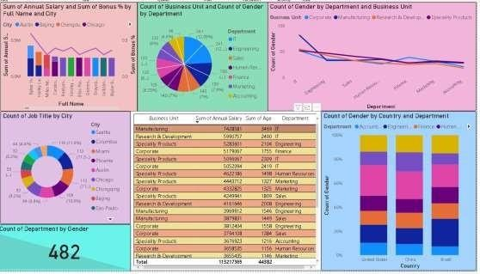

HERE. IS THE ACTUAL REPRESENATATION OPF POWER BI DASHBOARD USING THE ENPLOYEE DATA WITH ALL ASPECTS

Power BI dashboards are single-page documents, often referred to as canvas, which illustrate a story through visualizations. A well-designed dashboard consists only of the highlights of a story. This is due to the fact that it is limited to one page. For more information, readers can view related reports. Power BI is the only service that offers dashboards.

A single page visualization with multiple charts and graphs to tell a story is called a Power BI dashboard. This one-page visualization in a dashboard is also known as

a Canvas. The Power BI dashboard is a feature only available in Power BI Service. Since a Power BI dashboard is limited to one page, it only contains the highlights of a story. You cannot create a dashboard on Power BI Desktop.

1. SUM OF ANNUAL SALARY AND SUM OF BONUS %BY FULL NAME AND CITY

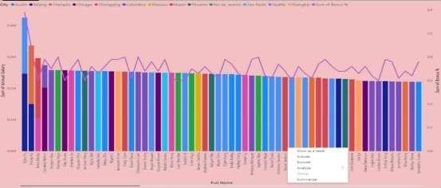

1. COUNT OF BUSINESS UNIT AND COUNT OF GENDER BY DEPARTM

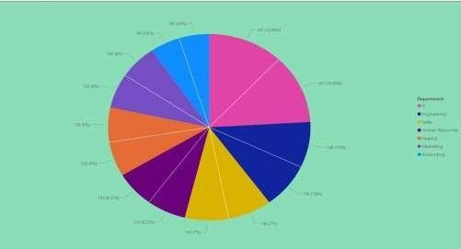

1. COUNT OF GENDER BY DEPARTMENT AND BUSINESS UNIT

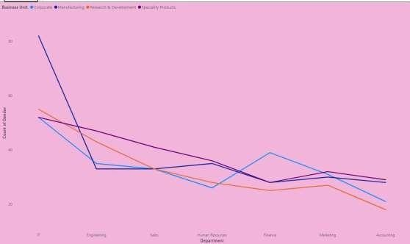

1. COUNT OF JOB TITLE BY CITY

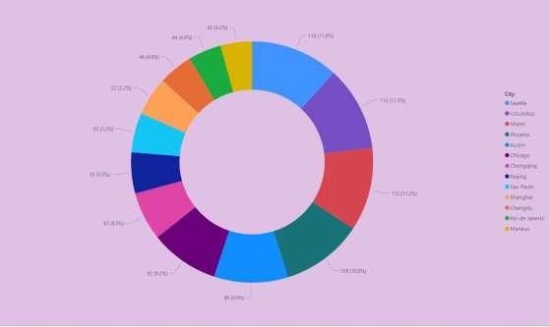

1. COUNT OF GENDER BY COUNTRY AND DEPARTMENT

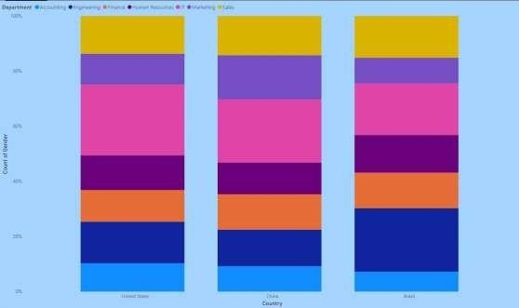

1. 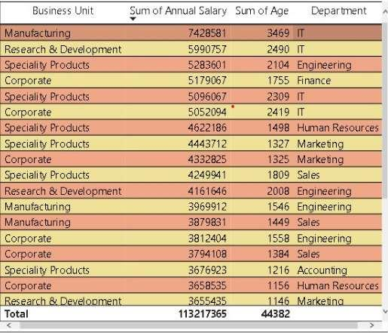SUM OF BUSINESS UNIT AND ANNUAL SALARY

SUM OF ANNUAL SALARY BY COUNTRY AND DEPARTMENT

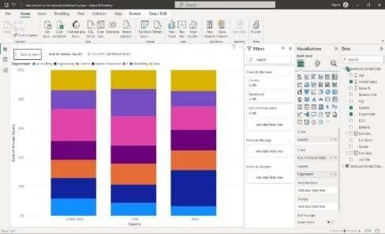

Above figure shows that united state has the Highest annual salary in IT department , lowest annual salary in Human resource department.

COUNT OF COUNTRY BY GENDER

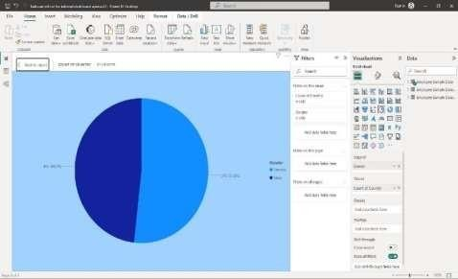

The above figure shows that the count of country by gender FEMALE has the Highest rate.

SUM OF BONUS BY JOB TITLE

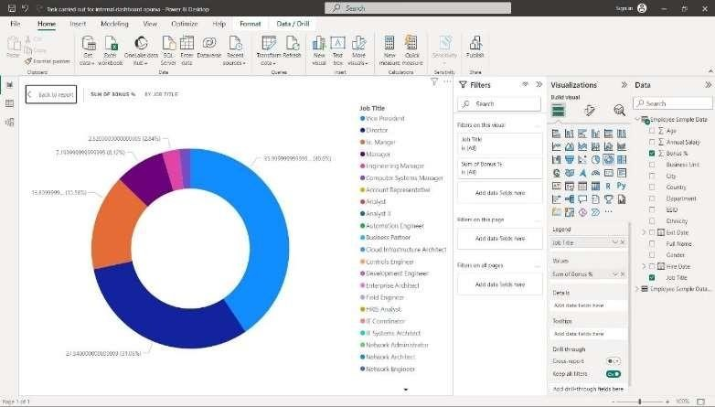

The above figure shows that the, Job title Vice president has the Highest % in annual bonus.

DASHBOARD

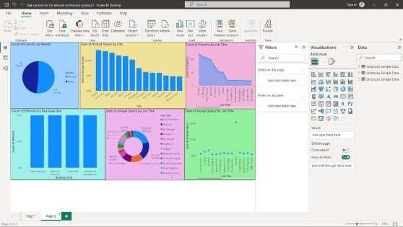

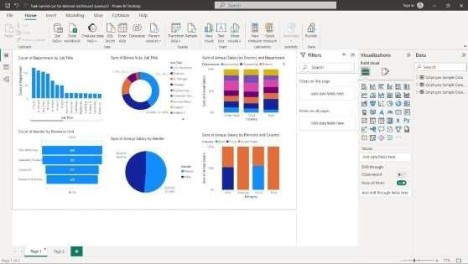

The above Dashboard shows the Bifurcation by Gender, Count of countries by their job title and the pie chart shows annual salaries of the employee, donut chart shows the bonus, also shows the departmental salary by their country by using Microsoft Power BI.

Conclusion:

The choice of BI tool is a function of organization’s need, user’s maturity and overall budget. Since, Indoor Systems Solution Pvt. Ltd. Has just started its journey towards a BI driven data culture and the end users have not yet been evolved fully, it was anonymously decided to go for Power BI as a data visualization tool with SQL server as a backend data mart. The idea is to explore deeper co- relation or discrepancies amongst various data points and visualize interactively through an effective data visualization application. Power BI primarily fulfils this objective.

My experience with Power BI has shown that it is a radical approach to simplifying the business intelligence and data analytics space, whereby individuals and organizations can easily provide data, build reports or have them automatically created, aggregate them in dashboards, and share it with minimal investment of time and effort.

To sum it all up, if your organization is Microsoft favored and has a group of Microsoft Excel power users, then the chances are very high that Power BI will work well within your organization. Professionals who work on charts, pivot tables, and formulas in Excel can use Power BI to quickly convert data into information.

Learnings from the Project:

The project has yielded several key learnings that can be valuable for both practitioners and organizations involved in web design and SEO analysis:

1. The importance of conducting comprehensive keyword research to identify relevant and high-ranking keywords that align with user intent.
2. The significance of on-page optimization, including meta tags, headings, URLs, and internal linking, in improving search engine visibility.
3. The value of creating high-quality, engaging, and optimized content that provides value to users and enhances search engine rankings.
4. The need for conducting a technical SEO audit to address technical aspects and ensure a seamless user experience.
5. The benefits of competitor analysis in understanding industry trends, identifying opportunities, and developing a competitive advantage.
6. The role of backlink analysis in establishing website authority and visibility through high- quality and relevant inbound links.
7. The importance of utilizing analytics and reporting tools to track website performance, user behavior, and conversions.
8. The significance of collaboration and knowledge sharing with industry professionals and experts to gain practical insights and enhance understanding.

OBSERVATIONS

* How to connect to and visualize data.
* It gives Real-time information.
* Cost- effective and Affordable.
* Excel Integration without comparing.
* Multiple dashboards developed in Power Bi.
* The power of Modern AI system at hand.

KEY LEARNING FROM A TASK CARRIED OUT

A Power BI report provides a very detailed overview of any dataset or data stream of interest in the form of different visualizations, filters, and parameters. It can vary depending upon one’s job role i.e., whether it is managing level or executive level.

Overall, Power BI provides a very large number of functionalities for data visualization and reporting purposes. In this article you learned in detail about different parts of Power BI Report, some Power BI Reports Examples, and differences between Power BI Dashboards.

Integrating and analyzing data from a huge set of diverse sources can be challenging, this is where Here comes into the picture.

Limitations of the Study:

* Microsoft Excel Power users will benefit best.
* Complex in Nature.
* Data Quality.
* Sometimes it does not handle data source properly.
* Bulky user Interface.
* Limited Sharing of data.

Future Scope :-

* Business Intelligence & Data warehousing is a very good & demanding field in Information Technology industry. Its present as well as future is very bright.
* Power BI is a really exciting product. It's fast paced, the Community is growing and really interactive, there are a bunch of ways to learn and interact.
* The major benefit I see is that it's an avenue to take the data that we have already been working with and helping business to make that data useful. Power BI is a tool that makes that really straightforward.
* To update the study/research work from time to time.

# 